Date: 2.08.2026
Review- 0

Title: AI-Powered Smart Driver Alert System

Team Members:
Name | Roll number
1. K. Varun Kumar Reddy | 2420090097
2. P. Eshwar Prasad Reddy | 2420090096
3. Md Jawwad | 2420030075
4. P. Shiva Kumar | 2420030030

Applications

AI-based driver drowsiness detection: An AI-powered computer vision system uses a camera to continuously monitor the driver's face and detects signs of drowsiness such as prolonged eye closure, frequent blinking, yawning, and head drooping in real time.

Driver distraction and attention monitoring: A computer vision model analyzes the driver's head pose, eye direction, and surrounding behavior to identify distractions such as looking away from the road or using a mobile phone while driving, generating an attention or risk score.

Real-time driver alert system: When the system detects drowsiness or dangerous distraction beyond a defined threshold, it generates immediate audio and visual alerts to regain the driver's attention and reduce the possibility of accidents.

Emergency SOS & safety monitoring: If a critical risk condition is detected or the driver manually activates an SOS feature, the system can share the driver's GPS location and emergency information with predefined contacts or a monitoring platform.

Limitations
- High dependency on camera quality and environmental conditions: Poor lighting, direct sunlight, night-time driving, camera obstruction, sunglasses, masks, or improper camera positioning can reduce the accuracy of facial and eye detection.
- AI model accuracy depends on diverse training data: The system requires high-quality and diverse datasets containing different drivers, facial characteristics, lighting conditions, driving environments, and drowsiness/distraction scenarios to reduce false alerts and missed detections.
- Real-time processing and hardware limitations: Continuous AI inference requires sufficient computational resources, and low-powered mobile or edge devices may experience latency while processing camera frames in real time.
- Privacy and security concerns: Continuous monitoring of the driver's face, behavior, location, and driving information creates privacy concerns and requires secure storage, authentication, and responsible handling of collected data.

Future Scope
  - Multi-sensor fusion: Integration of additional sensors such as steering-wheel sensors, heart-rate sensors, vehicle telemetry, accelerometers, and infrared cameras can improve driver-state detection beyond camera-only monitoring.
  - Federated learning: Federated learning can be used to continuously improve driver-monitoring models using data from multiple vehicles while reducing the need to transfer sensitive driver images to a central server.
  - Integration with Advanced Driver Assistance Systems (ADAS): The system can be integrated with vehicle safety systems to provide intelligent interventions such as adaptive warnings, lane-departure assistance, collision warnings, or controlled vehicle responses during critical situations.
  - Predictive driver-risk analysis: Historical driving behavior, drowsiness patterns, distraction frequency, driving duration, and environmental conditions can be combined to predict driver fatigue and provide personalized safety recommendations before a dangerous condition occurs.

4 Objectives:
- To develop an AI-based computer vision module that detects driver drowsiness by analyzing eye closure, blinking, yawning, and facial/head movements from a live camera feed in real time.
- To design an AI-based driver attention and distraction model that analyzes head pose, eye direction, and mobile-phone usage to classify the driver's condition as Normal, Distracted, Drowsy, or Critical and generate a corresponding risk score.
- To build a real-time driver alert and emergency SOS system that provides audio/visual warnings when dangerous driver behavior is detected and shares the driver's location during critical emergency situations.
- To implement a secure full-stack platform (FastAPI, React, MongoDB) with role-based authentication and a monitoring dashboard for storing driver events, analyzing safety statistics, viewing alerts, and managing emergency information.

Flow Chart of the Project:-

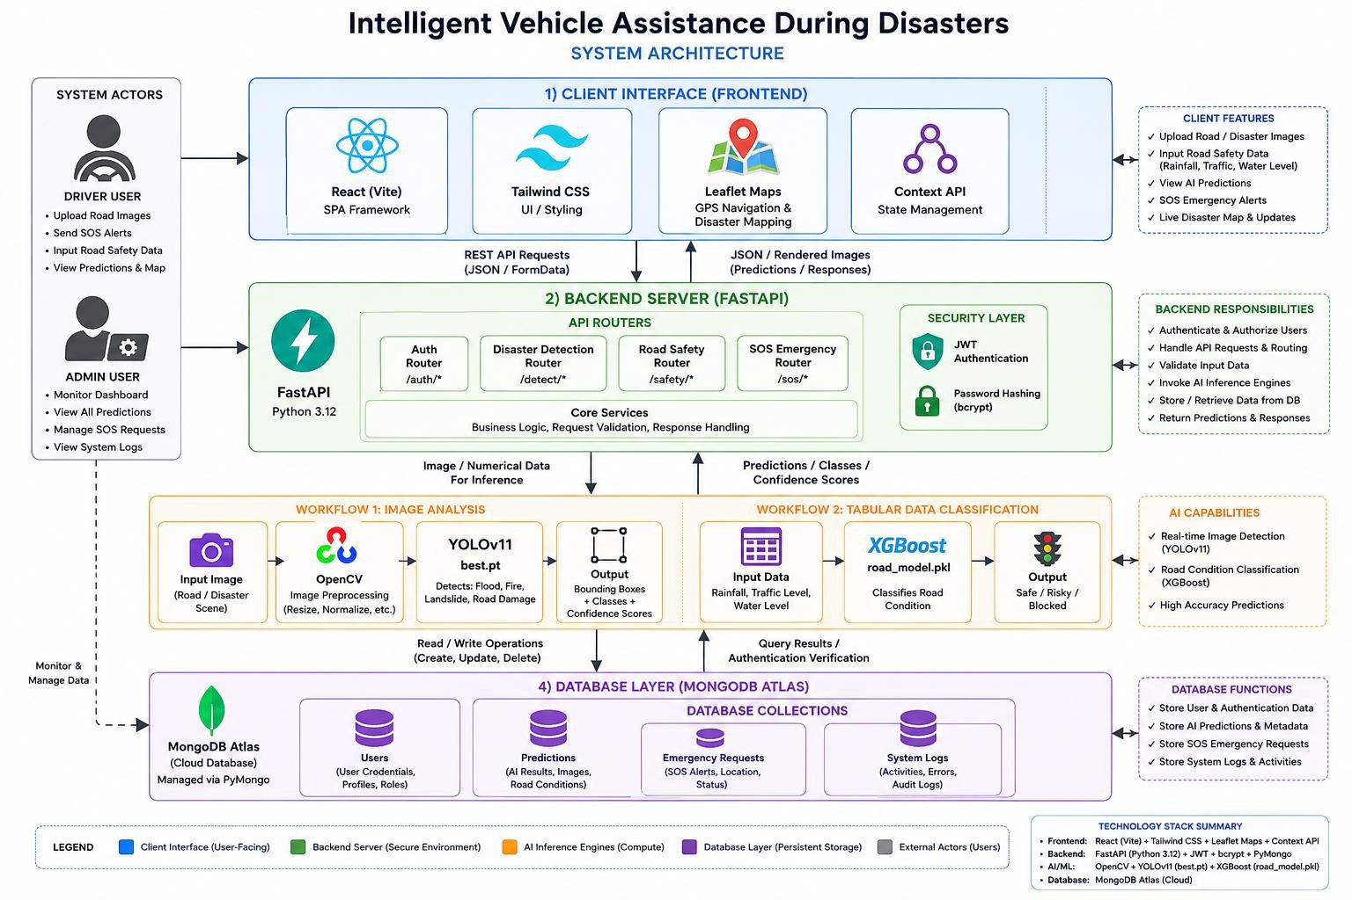

Methodology
The system architecture flowchart was developed using a layered architectural
methodology based on the technical specifications of the Intelligent Vehicle Assistance During Disasters system.

Component Identification
The system was first divided into its major components: React frontend, FastAPI backend, AI inference engines, and MongoDB Atlas database.

Layered Architecture Design
The components were organized into four layers:
  - Client Interface: React (Vite), Tailwind CSS, Leaflet Maps, and Context API.

  - Backend Server: FastAPI with API routers, JWT authentication, and bcrypt password hashing.
  - AI Inference Engines: OpenCV, YOLOv11 for image-based disaster detection, and XGBoost for road-condition classification.
  - Database Layer: MongoDB Atlas managed through PyMongo.

Data Flow Mapping
Arrows were used to represent communication between components:
  - Client ↔ Backend through REST API requests and JSON/FormData responses.
  - Backend → AI engines for image and numerical-data inference.
  - AI engines → Backend for predictions, classes, and confidence scores.
  - Backend ↔ Database for storing and retrieving system information.

AI Processing Workflows
Two major AI workflows were represented:
  - Image Analysis: Road/disaster image → OpenCV preprocessing → YOLOv11 (best.pt) → detected classes, bounding boxes, and confidence scores.
  - Road Classification: Rainfall, traffic level, and water level → XGBoost (road_model.pkl) → Safe/Risky/Blocked classification.

Security and Authentication Mapping
JWT authentication and bcrypt password hashing were included within the backend layer to show secure user authentication and authorization.

Database Mapping
MongoDB Atlas collections were connected to the backend to store users, predictions, emergency SOS requests, and system logs.

Visual Hierarchy and Styling
Different colors were assigned to each architectural layer to make the flowchart easy to understand:
  - 🔵 Blue — Client/Frontend
  - □ Green — Backend
  - □ Orange — AI/ML

  - □ Purple — Database
  - ⚫ Gray — System Actors

Final Refinement
Labels, arrows, technology names, model filenames, inputs, and outputs were refined so that the architecture diagram could independently communicate the complete system workflow.

